metin, ekran görüntüsü, yazı tipi, meneviş mavisi içeren bir resim

Açıklama otomatik olarak oluşturuldu

The Article Title [1]

**Name Surname[2] Name Surname[3]**

**Research Article Received:** xxxx **Accepted:**xxxxx

**Abstract:** In an abstract, concisely outline the study's purpose, scope, methodology, results, and conclusion. The abstract should be 200-300 words long, formatted in Times New Roman, 11pt font, with 6-0nk paragraph spacing, and single line spacing.

**Keywords:** Keyword, keyword, keyword (three-five words).

**Introduction**

The text should be composed using Times New Roman font at a size of 11 points. The spacing between lines should be set to single. For paragraph spacing, there should be 6 points before each new paragraph and 0 points after. Do not press the Enter key to create additional spaces between paragraphs; instead, rely on the specified paragraph spacing settings. Additionally, ensure that there is a single space after every punctuation mark and between each word to maintain proper formatting and readability.

**Literature Review**

First-level headings should be centered on the page. Second-level headings should be aligned to the left margin. Third-level headings should also be aligned to the left margin but should be in italics. All headings, regardless of their level, should have their first letters capitalized and should be formatted in bold text.

**Literature Review**

First-level headings should be centered on the page. Second-level headings should be aligned to the left margin. Third-level headings should also be aligned to the left margin but should be in italics. All headings, regardless of their level, should have their first letters capitalized and should be formatted in bold text.

***Literature Review***

First-level headings should be centered on the page. Second-level headings should be aligned to the left margin. Third-level headings should also be aligned to the left margin but should be in italics. All headings, regardless of their level, should have their first letters capitalized and should be formatted in bold text.

**Method**

The research should offer a comprehensive description of several key components. First, it should detail the research model being used. Next, it should clearly define the population and sample, or study group, involved in the research. The data collection instruments must be described, including an assessment of their validity and reliability. The methods used to collect the data should also be explained. Additionally, the techniques used for analyzing the collected data should be outlined. Finally, any limitations encountered during the study should be thoroughly detailed.

**Findings**

The research findings should be presented in a manner that aligns with the study's objectives. These findings can be effectively illustrated using tables, figures, graphs, or images. Each visual aid should be chosen based on its ability to clearly and accurately convey the relevant information. The use of these visual elements should enhance the understanding of the results and provide a clear representation of the data.

The tables included in the article should be formatted as follows: The title of each table should be left-aligned and capitalized. All text within the tables can either match the font size of the manuscript or be smaller, with a minimum size of 9pt.

Table 1.

The Name of the Table

|  |  |  |  |
| --- | --- | --- | --- |
|  | Scale 1 |  | |
| A | 10.10 | Use full stop for the decimal numbers. | |
| B | 10.20 |  |  |
| C | 10.30 |  |  |
| D | 10.50 |  |  |

* Footnotes about the table

Figures and graphics pertaining to your research should be organized as demonstrated below. The titles of figures and graphics should be positioned beneath them and written in the same font as the manuscript. They should be left-aligned, with each word beginning with a capital letter.

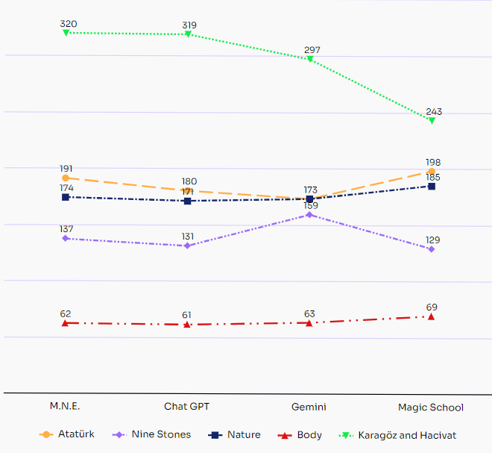

Figure 1. Total Words of Texts

**Direct Quotation Usage in the Text**

If a quotation surpasses 40 words, it should be segregated into a distinct paragraph, indented 1 cm from the left, without any quotation marks. Conversely, if quotations consist of fewer than 40 words, they should be incorporated within the existing paragraph, enclosed in quotation marks.

**Number Usage in the Text**

In your manuscript, express numbers from zero to nine in words. For numbers ten or greater, utilize digits, except in cases such as table numbers (e.g., Table 1), fractions (e.g., ¼, ½), graphical displays, numbers preceding units of measurement (e.g., 5 cm), and mathematical functions (e.g., multiplied by 5).

**Discussion**

The key concepts identified based on the research findings should be elucidated and analyzed. Recommendations can be proposed in alignment with the study's results. Furthermore, suggestions for future research and practical applications that will enrich the existing literature can also be provided.

**Conclusions**

In the conclusion section, distinct from the discussion, this study reflects on the significant findings and their implications.

**Acknowledgement**

**Ethics statement:** In this study, I affirm compliance with the rules outlined in the "Higher Education Institutions Scientific Research and Publication Ethics Directive" and assert that none of the "Actions Against Scientific Research and Publication Ethics" have been undertaken. Furthermore, we declare that there is no conflict of interest among the authors, that all authors have contributed to the study, and that full responsibility for any ethical violations rests with the article authors.

**Funding:** This research received no funding.

**Declaration of competing interest:** There is no conflicts of interest related to this submission.

**Institutional Review Board Statement**: The ethical approval for this study was obtained from the [Name of Ethics Committee]. Approval was granted on [Date of Ethics Committee Approval], and the document was assigned the reference number [Document Number].

**Copyrights:** licensed under a Creative Commons Attribution-Non-commercial 4.0 International License.

**References**

The references should be formatted according to APA 7 rules. Examples for commonly used types of sources are provided below. For more detailed information, refer to the APA 7 guidelines.

**Journal Article**

Bilge, H. (2023). More errors, better tesults? The relationship among high-stakes test achievement, reading error types, and reading fluency in different text types. *Reading & Writing Quarterly*, *39*(6), 491–509. https://doi.org/10.1080/10573569.2022.2142923

**Whole authored book**

Rasinski, T. (2004). *Assessing reading fluency*. Pacific Resources for Education and Learning.

**Whole edited book**

Kamil, M. L., Pearson, P. D., Moje, E. B. & Afflerbach, P. P. (Eds.). *Handbook of reading research.* Routledge.

**Chapter in an edited book**

Rasinski, T., Reutzel, D. R., Chard, D., & Linan-Thompson, S. (2016). Reading fluency. In M. L. Kamil, P. D. Pearson, E. B. Moje, & P. P. Afflerbach (Eds.), *Handbook of reading research* (Vol. 4, pp. 286–319). Routledge.

**Report by a Government Agency References**

National Reading Panel. (2000). *Teaching children to read: An evidence-based assessment of the scientific research literature on reading and its implications for reading instruction*. National Institute of Child Health Human Development. <https://www.nichd.nih.gov/sites/default/files/publications/pubs/nrp/Documents/report.pdf>

**Ethics Code References**

American Counseling Association. (2014). *2014 ACA code of ethics.* <https://www.counseling.org/docs/default-source/default-document-library/ethics/2014-aca-code-of-ethics.pdf?sfvrsn=55ab73d0_1>

**Conference presentation**

Altundal, B. & Bilge, H. (2023, May 21-22). *The effect of echo reading method on bilingual 8th grade students*  [Conference presentation]. 5th International Congress of Multidisciplinary Social Sciences, Ankara, Türkiye. https://en.icmuss.org/

**Abstract of a conference presentation**

Altundal, B. & Bilge, H. (2023, May 21-22). *The effect of echo reading method on bilingual 8th grade students*  [Conference presentation abstract]. 5th International Congress of Multidisciplinary Social Sciences, Ankara, Türkiye. <https://en.icmuss.org/>

**Published Dissertation or Thesis References**

Bilge, H. (2019). *The relationships between reading, writing, and speaking fluencies, reading comprehension and vocabulary* [Doctoral dissertation, Gazi University]. Yükseköğretim Kurulu Başkanlığı Tez Merkezi. <https://tez.yok.gov.tr/UlusalTezMerkezi/>

**Webpage on a news website**

Castro, D. & McLaughlin. (January, 2021). *Who is winning the AI race: China, the EU, or the United States?- 2021 update.* Center for Data Information. <https://datainnovation.org/2021/01/who-is-winning-the-ai-race-china-the-eu-or-the-united-states-2021-update/>

1. doi: https://doi.org/
2. Corresponding Author ,e-mail, Kafkas University, Türkiye, ORCID:
3. Author, Kafkas University, Türkiye, ORCID: https://orcid.org/